**CHAPTER 1**

**INTRODUCTION**

**1.1 History**

We have taken inspiration from an automatic task management system at industries for goods handling. The proposed project can be efficiently used for the organizations where the controller can reach out the mass for teaching or announcing regular updates from far distance via audio-video calling option. Henceforth, this concept can provide a user-friendly experience to staff, teachers and students. By the previous, the robot will act as a smart announcer and in case of an emergency, it can navigate people towards a safer area or an environment.

In the future work the onboard smart doctor facility will be provided which will sense the patient’s health using sensors and at the same time will send the information to a nearby hospital for real doctor intervention. To summarize, this paper introduces a robot which will move around in your workspace, recognizes queries and adjust to individual preferences to render improvised learning experience. The concept will also define the conversion of all the conventional workspace chores into digitalized activities and then assembling the later into a single social robot. In the near future, this social robot will be capable of performing all human-like activities with proper task accomplishment and enabled notifications to the UI interface

**1.2 Project overview**

Multimedia applications are very common in institutions whether colleges or schools. In this project a combined solution for institutional monitoring is studied and hence it becomes a need to develop a next-generation robot which is smart, interactive and uniquely mobile. For years, science fiction has been promising us robotic servants to make our lives more interesting and easier and hence, the wants and desires of a number of people who really believed that the future is NOW, it is possible for them to have a robot just like the ones they see on TV. This social robot will prove to be a helping hand around our workspace. The effectiveness of this project requires a multi-disciplinary analysis using engineering, psychological and educational approaches.

**CHAPTER 2**

**LITERATURE SURVEY**

* 1. **MayankYadva, Anmol Aggarwal, NitinRakesh, "Motion Based Attendance System in Realtime Environment for Multimedia Application", Department of Computer Science and Engineering, Amity School of Engineering and Technology, Uttar Pradesh, Noida, India. ©2018 8th International Conference on Cloud Computing, Data Science & Engineering.**

**Abstract *-*** Modern classrooms are equipped with various smart devices that have supporting software to improve the classrooms. It’s often seen that the precious time of class is wasted on taking attendance, or the class may face various interruptions due to late entries of student and this attendance procedure is repeatedly done. Also, the performance is affected by the presence of students in the institute.

To overcome this the conventional system of attendance is replaced by taking attendance through the sensor-based card (RFID sensor) or biometric finger printing. The motion-based attendance system that assist recording and management of attendance that will be used for various institutions and the colleges.

**Introduction *–*** the conventional method of taking attendance is old though are still in practice, due to which precious time of class room is wasted on taking attendance and which also causes manual error at times or the late entries lead to repeated process. Thus, all the attendance is been analysed and maintained manually by the faculties. Also, we are not sure about the count of students attending full class. Hence the data is stored manually and can cause errors which leads to false count of attendance. Thus, there is a need of motion-based attendance management system which will assist the faculties and institute or can also assist people in any work place where the attendance of the employ is been taken on manual basis. This system not only maintains the data but also reduces the human efforts and energy.

**Conclusion*-*** the main idea behind this project is to develop an attendance maintenance system for various schools, colleges and as well as institutions /organisations. The system provides an efficient method of monitoring the attendance using face recognition. The system is cost efficient, simple to use, easy to implement, secure and simple design.

This system mainly works on the efficiency of the HMM model which overcomes many disadvantages of Principal Component Analysis, hence offers better face detection with less storage requirement and offers better than manual, or RFID sensor system, it completely does the work automatically, hence saves a lot of time and stops wastage in maintaining manual records. So, the system works well and should be installed not only in schools or institutions but also in offices and work places or also where attendance is marked manually.

In future, system can be used for the surveillance in the campus and also the system can be used for institution detection system.

* 1. **Joni Rasanen, Marko Viitanen, JarnoVanne, TimoD.Hamalainen, "Kvazzup; Open Software for HEVC Video Calls", Laboratory of Pervasive Computing Tampere University of Technology, Finland. ©2017 IEEE International Symposium on Multimedia.**

**Abstract—** This paper introduces an open-source HEVC video call application called Kvazzup. This academic proposal is the first HEVC-based end-to-end video call system with a user-friendly Graphical User Interface for call management. Kvazzup is built on the Qt framework and it makes use of four open-source tools: Kvazaar for HEVC encoding, Open HEVC for HEVC decoding, Opus codec for audio coding, and Live555 for managing RTP/RTCP traffic.

In our experiments, Kvazzup is prototyped with low-complexity VGA and high-quality 720p video calls between two desktops. On an Intel 4-core i5 processor, the VGA call accounts for 17% of the total CPU time. Averagely, it requires a bit rate of 0.31 Mbit/s out of which 0.26 Mbit/s is taken by video and 0.05 Mbit/s by audio. In the 720p call, the respective figures are 46%, 1.13 Mbit/s, 1.08 Mbit/s, and 0.05 Mbit/s. These test cases also validate the feasibility of HEVC in different types of video calls. HEVC coding is shown to account for around 34% of the Kvazzup processing time in the VGA call and 45% in the 720p call.

**Introduction *-***This academic proposal is based on end to end video call system with a user-friendly Graphical User Interface for call management. This system is prototyped with low complexity VGA and high quality 720p video calls between two desktops. One of the drivers behind this growth is video communications fostered by advanced video features in consumer devices, faster IP networks, and popular Internet video telephony services such as Skype with 300 million active users already. Particularly, two-party video calls and multi-party video conferencing are increasingly used in the business sector where IP traffic is expected to be three times as high by 2021. Mitigating this exponential growth means taking efficient video compression into use in video call applications.

**Conclusion *-*** This paper presented an end-to-end HEVC video call system Kvazzup. It is the first open-source solution featuring the latest video and audio codec’s for economic communication as well as a GUI for convenient call management. The proposed setup uses Kvazaar for HEVC encoding, Open HEVC for HEVC decoding, Opus codec for audio coding, Live555 for media delivery, and SIP for initiating and ending a call. The system also validates the feasibility and benefits of HEVC in a video call. Kvazzup is capable of running on a modest desktop at 720p30 resolution.

In the future, the proposed system will be extended to support multi-party video conferencing and higher video resolutions. This way, communication between larger number of participants can be served with improved user experience.

* 1. **https://www.startengine.com/aido**

This website describes about the social robot which is capable of performing human activities with proper task accomplishment notifications to UI interface. The website defines the conversion of all the conventional workspace chores into digitalized activities and then assembling the later into a single social robot.

This website defines us to AIDO which is a next generation home robot, a beautifully crafted home robot that is a showpiece for robotic innovation. AIDO is an interactive personal home robot, it’s an all in one package that comes with the best of home automation, security, assistance, entertainment and much more. This a smart interactive and uniquely mobile which can play with kids, helps with household chores, can handle the schedules and keep homes safe and secure

* 1. **https://www.indiegogo.com/projects/aido-next-gen-home-robot.**

This website describes about the specifications of robotic actuations and all the required mechanical components. The robot will use Android Bluetooth API (Application Program Interface) for command transmission and hence the complete system will be wireless, adaptable and cost-effective. The robot study is been done from this website, the website defines us different functions carried out by the robot, which involves the movement of the robot till the working of the same. the robot is studied on the basis of its ability to interact, mobility, security and many more. These prepossessing features of the robot makes it more engrossing and charismatic.

**CHAPTER 3**

**PROPOSED WORK**

**3.1 Attendance module**

**3.1.1 Introduction**

The RFID technology can access the biometric data of students one by one and allow student’s entrance into the class. Proximity sensor is an add on feature; It can sense the student’s proximity of approaching objects. The proximity sensor is placed near the RFID sensor, when the student enters the class without punching/swiping the card then the buzzer will be enabled. Hence, it helps to avoid false attempts. When there are continuous classes by different faculty the QR code will be displayed on the screen via projector. The students can scan it through their smart phones via app provided by the administration. All faculty will be given an individual QR code with the data base of the student embedded into it. This way attendance will be taken more precisely and a lot of time will be saved.

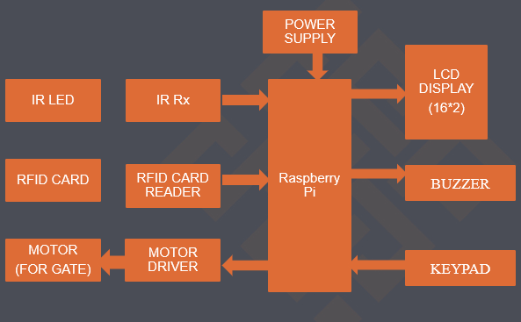

*Figure 3.1: Block diagram of attendance module*

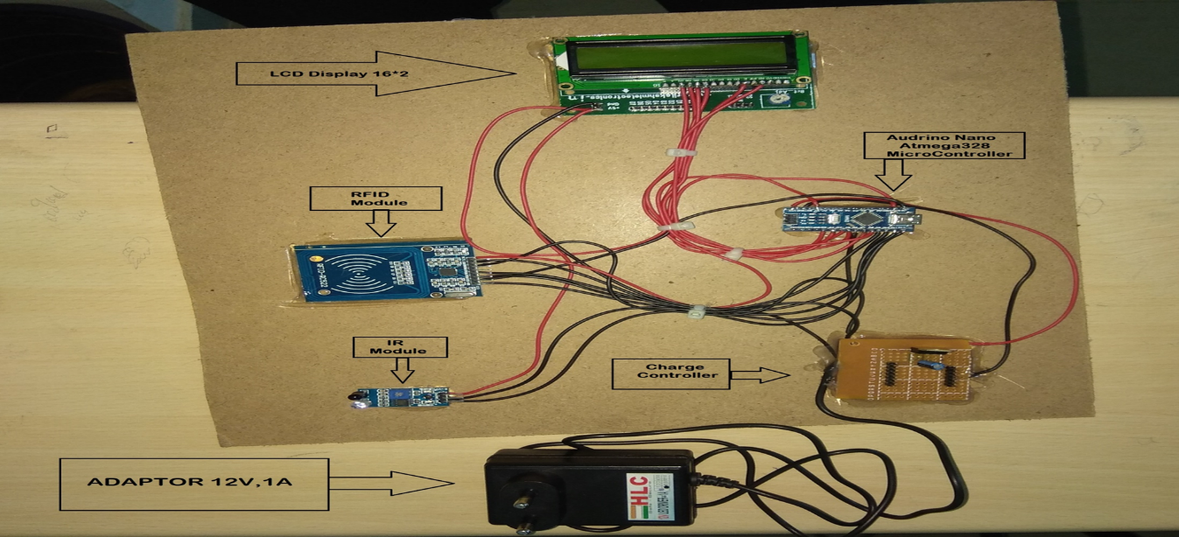

*Figure3.2:Attendance module setup*

**3.1.2 RFID Technology**

RFID is an acronym for “radio-frequency identification” and refers to a technology whereby digital data encoded in RFID tags or smart labels are captured by a reader via radio waves. RFID is similar to barcoding in that data from a tag or label are captured by a device that stores the data in a database. RFID, however, has several advantages over systems that use barcode asset tracking software. The most notable is that RFID tag data can be read outside the line-of-sight, whereas barcodes must be aligned with an optical scanner.

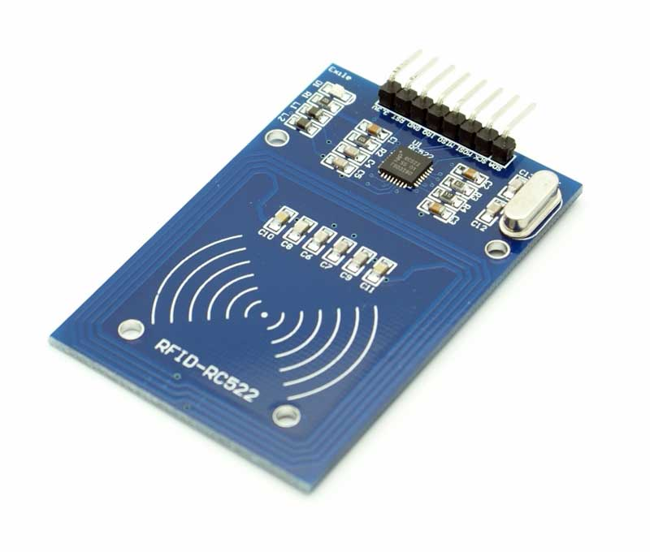

*Figure 3.3:RFID card reader*

**3.1.3 Proximity Sensor**

A sensor that can be used for detecting the presence of objects surrounding it without having any physical contact is termed as a proximity sensor. This can be done using the electromagnetic field or electromagnetic radiation beam in which the field or return signal changes in the event of the presence of any object in its surrounding. This object sensed by the proximity sensor is termed as a target

.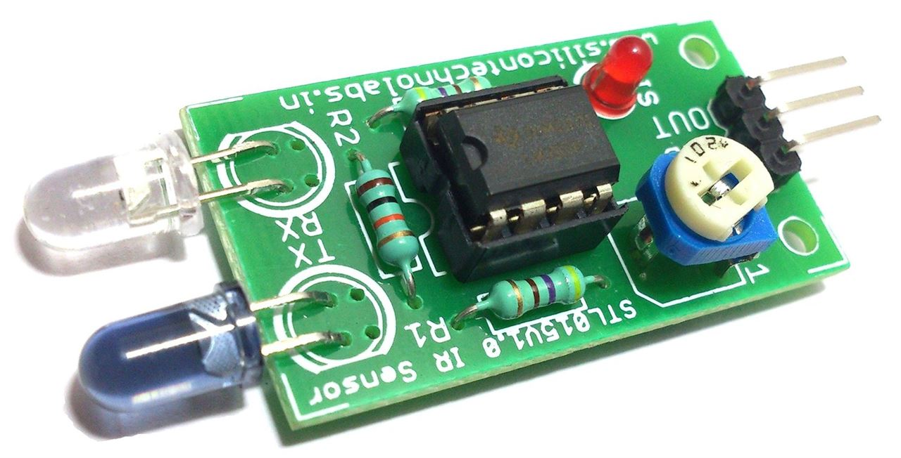

*Figure 3.4:Proximity sensor*

Thus, if we discuss about different types of targets such as plastic target, metal target, and so on requires different types of proximity sensors such as capacitive proximity sensor or photoelectric proximity sensor, inductive proximity sensor, magnetic proximity sensor and so on. The range in which the proximity sensor is able to detect an object is termed as nominal range. Unlike the other sensors, proximity sensors can last for long life and have very high reliability as there are no mechanical parts as well as no physical contact exists between the sensor and sensed object.

**3.1.4 Working of Attendance Module**

RFID belongs to a group of technologies referred to as Automatic Identification and Data Capture (AIDC). AIDC methods automatically identify objects, collect data about them, and enter those data directly into computer systems with little or no human intervention. RFID methods utilize radio waves to accomplish this. At a simple level, RFID systems consist of three components: an RFID tag or smart label, an RFID reader, and an antenna. RFID tags contain an integrated circuit and an antenna, which are used to transmit data to the RFID reader (also called an interrogator). The reader then converts the radio waves to a more usable form of data. Information collected from the tags is then transferred through a communications interface to a host computer system, where the data can be stored in a database and analysed at a later time.

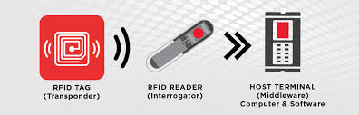

*Figure 3.5: Methodology of attendance system*

**3.2 Two-Way Communication**

**3.2.1 Introduction**

Two-way communication is a form of transmission in which both parties involved transmit information. Two-way communication has also been referred to as interpersonal communication. One-way communication is when a message flows from sender to receiver only, thus providing no feedback. Some examples of one-way communication include: radio or television programs or even listening to policy statements from top executives. Two-way communication is especially significant in that it enables feedback to improve a situation.

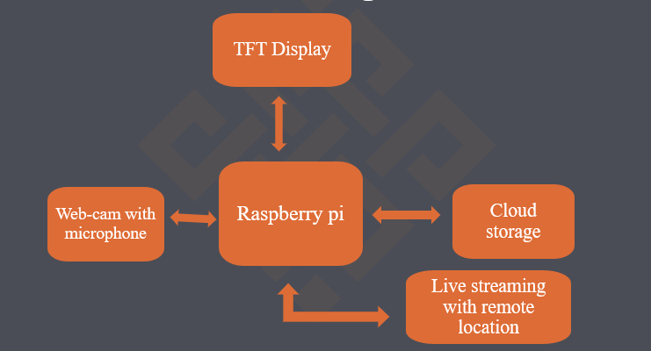

*Figure 3.6: Block diagram of two-way communication.*

**3.2.2 Raspberry Pi with Display Screen**

Raspberry Pi is the name of a series of single-board computer that runs Linux, but it also provides a set of GPIO (general purpose input/output) pins that allow you to control electronic components for physical computing and explore the Internet of Things (IoT).

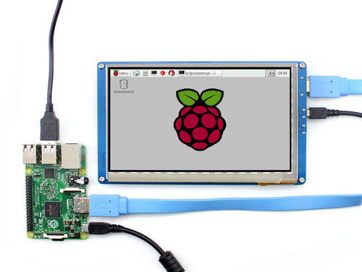

*Figure 3.7: setup of raspberry pi with screen*

|  |  |
| --- | --- |
| SoC | Broadcom BCM2837 |
| CPU | 4× ARM Cortex-A53, 1.2GHz |
| GPU | Broadcom Video Core IV |
| RAM | 1GB LPDDR2 (900 MHz) |
| Networking | 10/100 Ethernet, 2.4GHz 802.11n wireless |
| Bluetooth | Bluetooth 4.1 Classic, Bluetooth Low Energy |

*Table 3.1: Specification of raspberry pi*

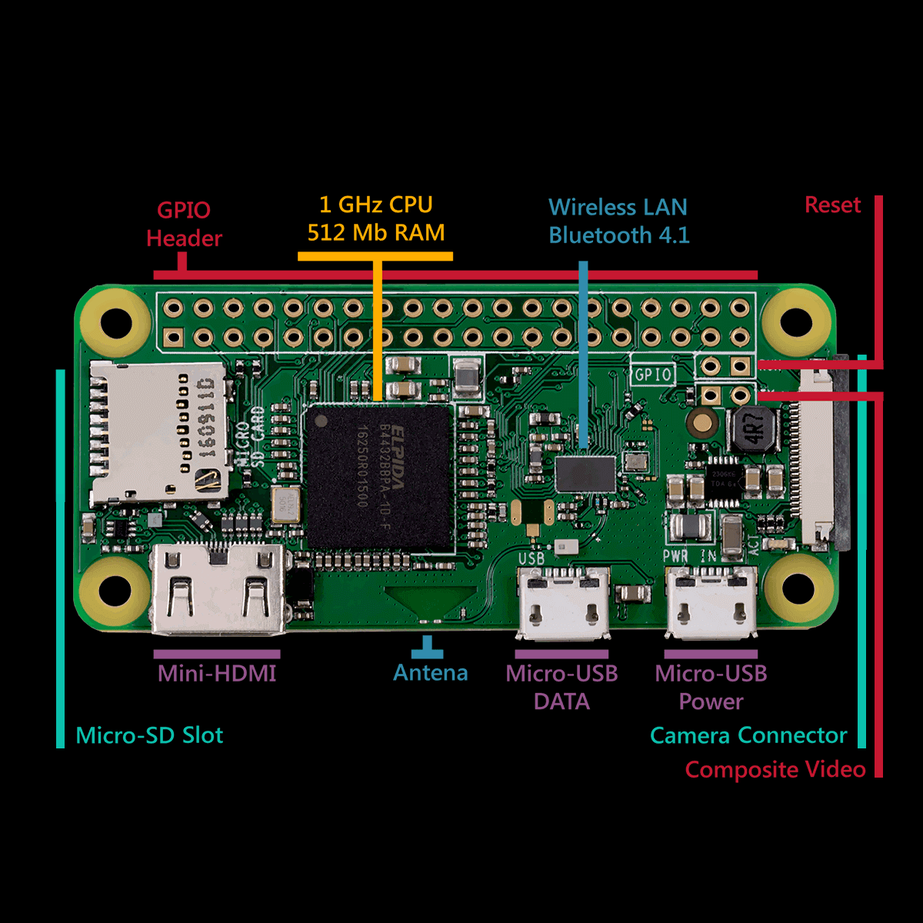

*Figure 3.8: Raspberry pi specification*

**3.3 Smart Navigation**

**3.3.1 Introduction**

With the patrol mode of the robot it can render to different places. Help people navigate the location easily. Provide necessary medical help and easily accessible to physically challenged people. Hence can-do multiple function in a fraction of time.

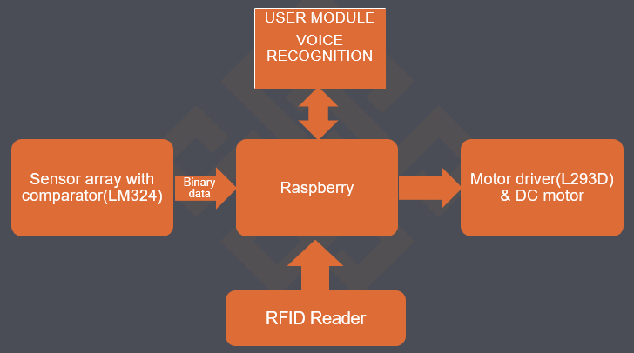

*Figure 3.9: Block diagram of smart navigation.*

**3.3.2 DC motor**

The DC motor works over a fair range of voltage. The higher the input voltage more is the RPM (rotations per minute) of the motor. For example, if the motor works in the range of 6-12V, it will have the least RPM at 6V and maximum at 12 V.

In terms of voltage, we can put the equation as:

RPM= K1 * V, where,

 K1= induced voltage constant

V=voltage applied

The working of the gears is very interesting to know. It can be explained by the principle of conservation of angular momentum. The gear having smaller radius will cover more RPM than the one with larger radius. However, the larger gear will give more torque to the smaller gear than vice versa. The comparison of angular velocity between input gear (the one that transfers energy) to output gear gives the gear ratio. When multiple gears are connected together, conservation of energy is also followed.  The direction in which the other gear rotates is always the opposite of the gear adjacent to it.

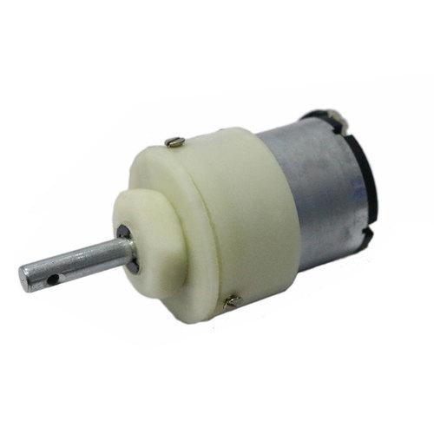

*Figure 3.10 : 12V DC motor for robot traction*

In a geared DC motor, the gear connecting the motor and the gear head is quite small, hence it transfers more speed to the larger teeth part of the gear head and makes it rotate. The larger part of the gear further turns the smaller duplex part. The small duplex part receives the torque but not the speed from its predecessor which it transfers to larger part of other gear and so on. The third gear’s duplex part has more teeth than others and hence it transfers more torque to the gear that is connected to the shaft.

**3.3.3 Arduino Uno**

Arduino Uno is a microcontroller board based on the ATmega328P (datasheet). It has 14 digital input/output pins (of which 6 can be used as PWM outputs), 6 analog inputs, a 16 MHz quartz crystal, a USB connection, a power jack, an ICSP header and a reset button. It contains everything needed to support the microcontroller; simply connect it to a computer with a USB cable or power it with a AC-to-DC adapter or battery to get started.

|  |  |
| --- | --- |
| Microcontroller | ATmega328P |
| Operating Voltage | 5V |
| Input Voltage (recommended) | 7-12V |
| Input Voltage (limit) | 6-20V |
| Digital I/O Pins | 14 (of which 6 provide PWM output) |
| PWM Digital I/O Pins | 6 |
| Analog Input Pins | 6 |
| DC Current per I/O Pin | 20 mA |

*Table 3.2 : Specification of arduini Uno*

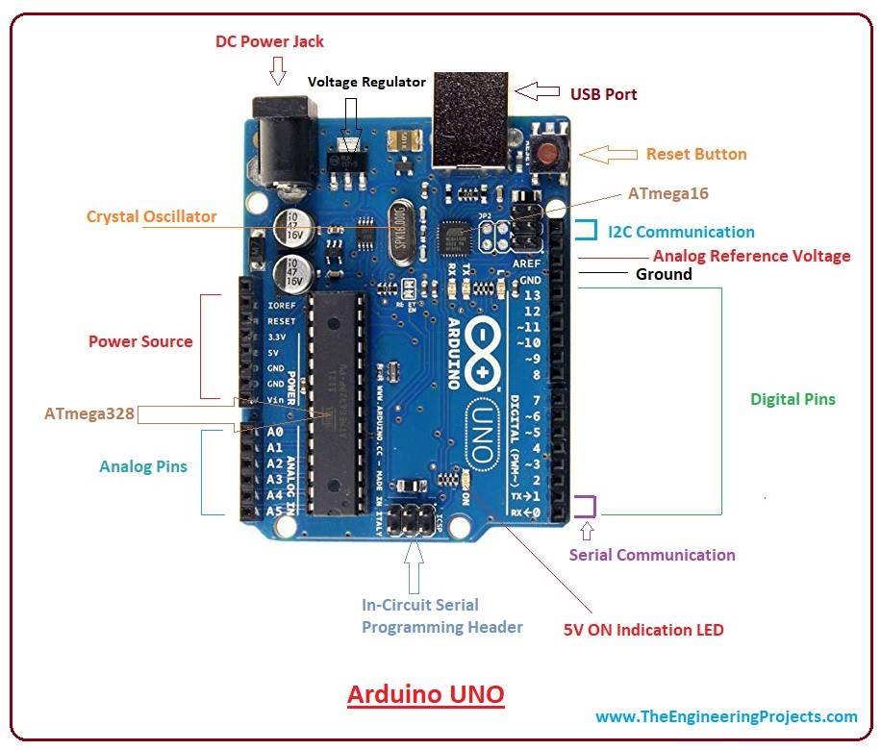

*Figure 3.11 : Arduino UNO pin diagram*

**3.4 Additional Features**

The project has many additional features which includes the following application

* access to E-library.
* First aid with live advice from doctor via video call.
* Robot anti-theft protection system.
* Fetching of E-noted and books via pen drive or Email.

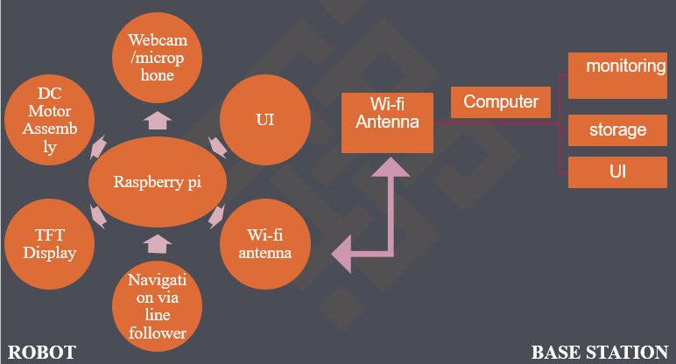

*Figure 3.12 : Block diagram of autonomous surveillance robot for institutional application.*

**3.5 Final Project Outlook**

The interpretation drawn after completion of the full-fledged project is that it’s a multi utility robot. The robot is equipped with many applications that will ease the institutional workload and improve education handling. The rover is interfaced with IR sensor, ultrasonic sensor, buzzer, 5-inch display screen, speaker, camera with inbuilt microphone. The system is programmed using raspberry pi and Arduino UNO. The video communication, attendance database, E-library status and class-notes are operated using raspberry pi loaded with 16GB memory card.

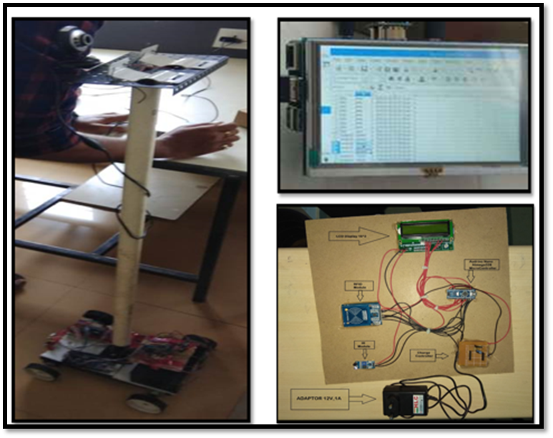

*Figure 3.13:Final project outlook*

The movement of robot is based on the principle of path following concept. The controlling unit of robot is at two locations, one with control room and other lies at different nodal points where the attendance module is placed (door of every classroom). The ultrasonic sensor along with the buzzer provide anti-theft protection. The robot is spacious which can be used to carry basic classroom utilities along with it (chalk, duster, marker, etc). The additional application mentioned above can also be fulfilled using this multi-tasking robot called autonomous surveillance robot. The overview of the project is shown below.

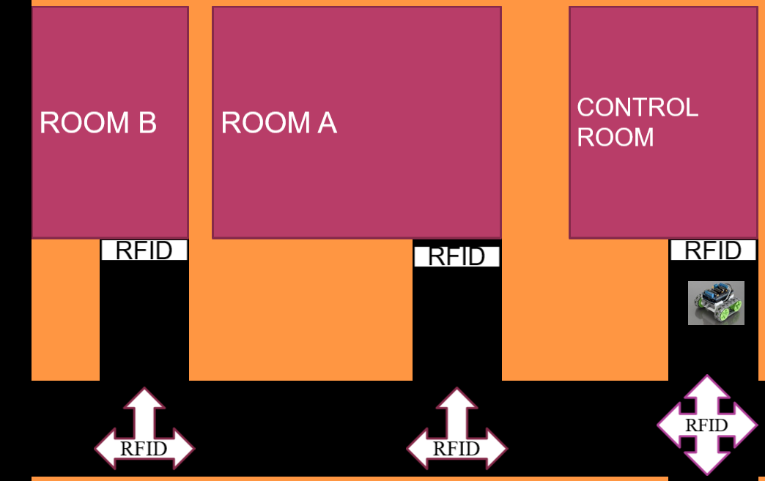

*Figure 3.14: Movement of the robot*

**CHAPTER 4**

**RESULT ANALYSIS**

Wedeveloped a robot which is capable of doing or can perform the tasks which is preferably performed in the institutions and many work places or other education based work places. The major tasks that are performed by the robot are: -

**4.1 Smart attendance system.**

The attendance system is so developed which will be time and cost efficient .The attendance system is been developed using the RFID cards, IR module, RFID card reader, an LCD display 16*2 and Arduino Nano Atmega 328 microcontroller .the data taken by the RFID reader will be stored which can later be used and can be monitored accordingly.

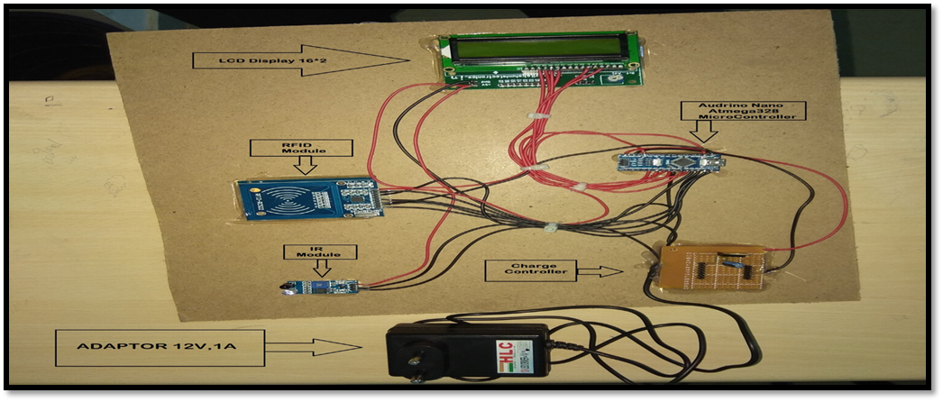

*Figure 4.1: Attendance module setup.*

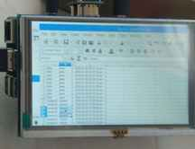

*Figure 4.2: Attendance data storage*

**4.2 Navigation.**

With the patrol mode of the robot it can render to different places. Help people navigate the location easily. Provide necessary medical help and easily accessible to physically challenged people. Hence can-do multiple function in a fraction of time.

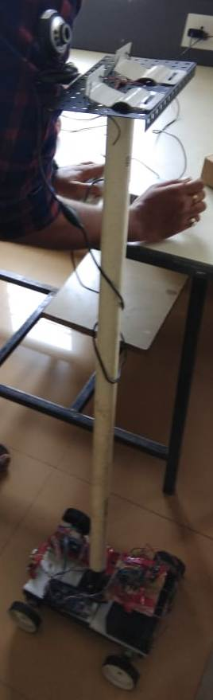

*Figure 4.3: Completed project setup*

**4.3 Video conference.**

Two-way communication is a form of transmission in which both parties involved transmit information. Two-way communication has also been referred to as interpersonal communication. One-way communication is when a message flows from sender to receiver only, thus providing no feedback. Some examples of one-way communication include: radio or television programs or even listening to policy statements from top executives. Two-way communication is especially significant in that it enables feedback to improve a situation.

**4.4 Digital library & E-notes***.*

The students can monitor the availability of books in library from this system where the data about all the available books will be feed and later the students can easily fetch data of their requirement. The concept of e-notes is been carried out using the storage device in the system where the notes of the particular subject will be entered and later the data can be used or can be transferred by and external storage device making it easy for the students to be updated by the availability of notes.

**CHAPTER 5**

**CONCLUSION AND FUTURE SCOPE**

**5.1 Conclusion**

This autonomous surveillance robot is a cutting-edge robot which is smart, interactive and remarkably mobile. The robot perceives questions and changes with the individual preferences and on a particular’s requirements, which changes to individual inclinations and its audio and visual effects and the illustrations and development are made for an intuitive learning background. The robot is developed so as it can move in the work space to render improvised lifestyle.

The application of this robot makes it more interesting and appealing. It is a smart announcer which is preferably to reduce the human effort or any physical efforts. Any announcements can be transferred to the mass by the controller using this application or robot. It has an audio video correspondence which will provide us with the monitor to monitor video conference in the absence of the individual. The database can be stored in this system which can help in future evaluation and also the database management of all the monitored data.

The major application is of the smart navigation which takes an individual towards an more secure condition, this will be an good application for the visually challenged individuals so as to navigate themselves to a particular destination in the workplace.

**5.2 Future Scope**

This social robot will be fit and helpful for playing out the entire human like exercise leading to less human strain on a particular work which will be capable enough for any appropriate undertaking achievements and an empowered notice to the UI interfacing.

This can provide an onboard smart doctor facility which will detect the patient’s well-being by utilizing the sensors and in the meantime will send the details about the individuals data to the nearest available doctor or to the close by emergency clinic.

**REFERENCES**

**Journal / Conference Papers/ web**

[1] MayankYadva, Anmol Aggarwal, NitinRakesh, "Motion Based Attendance System in Realtime Environment for Multimedia Application", Department of Computer Science and Engineering, Amity School of Engineering and Technology, Uttar Pradesh, Noida, India. ©2018 8th International Conference on Cloud Computing, Data Science & Engineering.

[2] Joni Rasanen, Marko Viitanen, JarnoVanne, TimoD.Hamalainen, "Kvazzup; Open Software for HEVC Video Calls", Laboratory of Pervasive Computing Tampere University of Technology, Finland. ©2017 IEEE International Symposium on Multimedia.

[3] https://www.startengine.com/aido

[5] https://www.indiegogo.com/projects/aido-next-gen-home-robot.